**NAME :** PETER VISUWASAM C

**DEPARTMENT :** INDUSTRIAL BIOTECHNOLOGY

**COLLEGE :** GOVERNMENT COLLEGE OF TECHNOLOGY, COIMBATORE

**NAAN MUDHALVAN COURSE:** DIGITAL MARKETING

**NAAN MUDHALVAN ID :**E88DFA60D879047939D49D2A545B167B

**ASSIGNMENT ON DIGITAL MARKETING**

1. Create a blog or website using blogspot and wordpress. Customize

the theme design and post new article with 500 words.

BLOGSPOT:

<https://wanderlustvoyagevista.blogspot.com/2023/10/nourishing-your-body-journey-into.html>

WORDPRESS:

<https://naturelovenatureblog.wordpress.com/2023/10/30/your-body-a-journey-into-healthy-foods/>

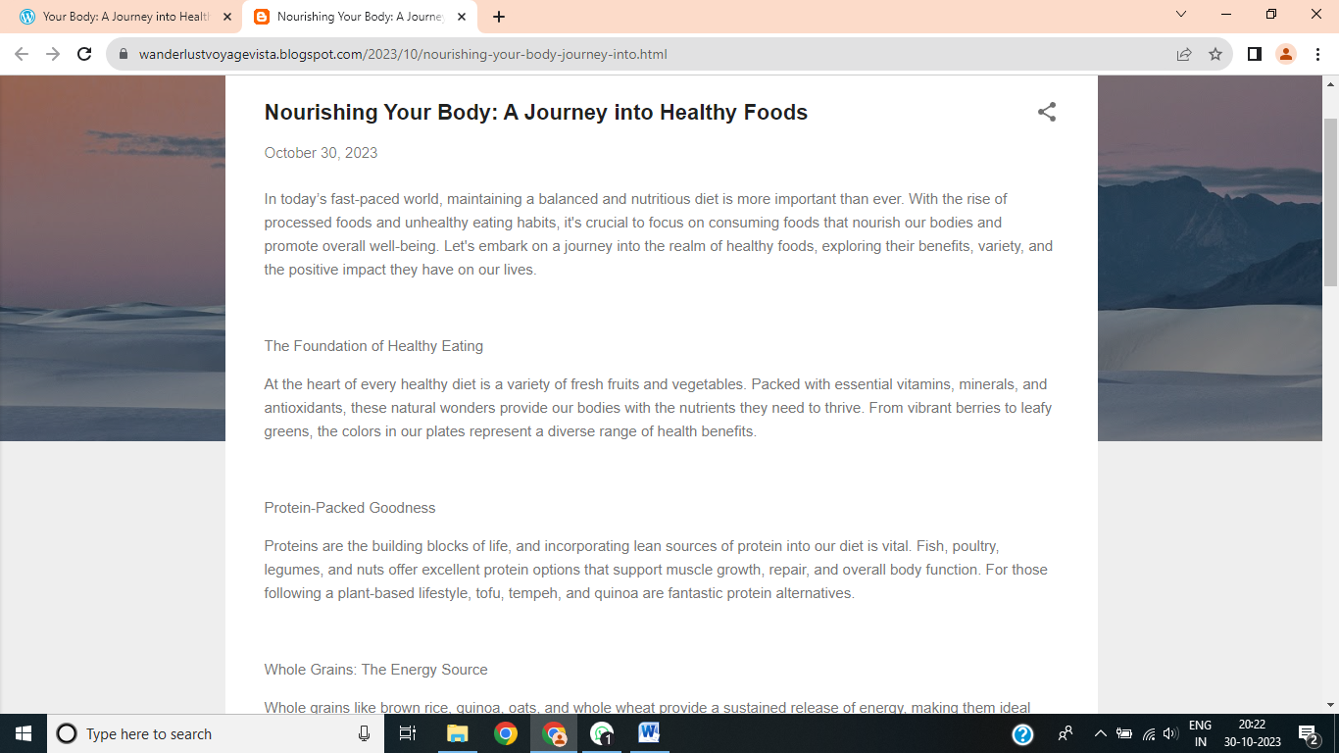

2.Create a new facebook business page and post one social media poster

for your brand.

[https://www.facebook.com/photo/?fbid=122094846320103592&set=a.122094846878103592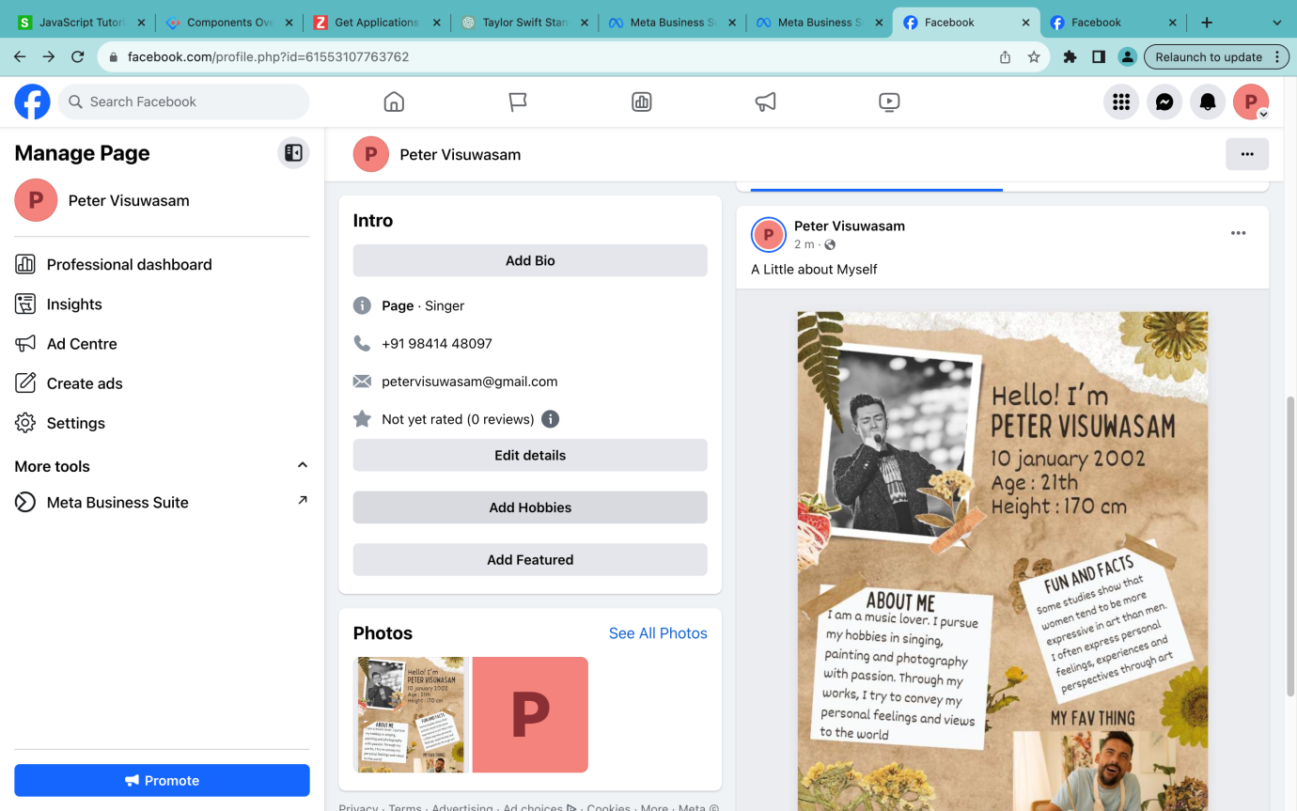](https://www.facebook.com/photo/?fbid=122094846320103592&set=a.1220948)

3.Create and design a social media advertisement poster using canva.

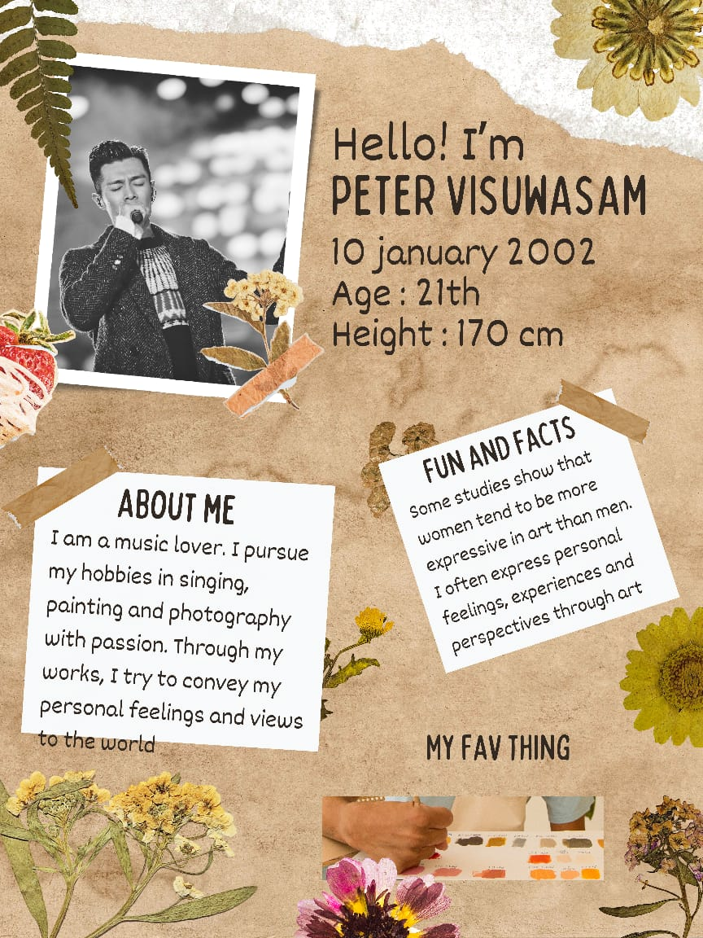

4. Create email newsletter design using Mailchimp or canva tool.

